January 19, 2014
fit City

Josh Hopps
4456 S. Arcade Lane
Holladay, Utah 84121
Dear Mr. Hopps
Thank you for your interest in our fitness facility. Our brand new gym offers the best equipment, popular fitness classes, and personal training opportunities without an intimidating environment. We guarantee we can offer you the best fitness experience possible and help you reach your personal goals. Our facilities offer a number of services including:
- Fitness classes
  - Schedules posted online and in each of our locations
- Tanning
  - Unlimited tanning with your membership
- Child Care
  - Hours posted online and in each of our locations
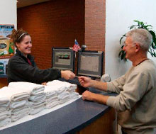
Please let us know if you have any questions regarding our facility locations, services, and pricing. We are here to help you achieve your personal fitness goals. For a free seven day trial bring this attached flyer in to your preferred location.
Sincerely,
Katie
Manager

We are here to help you achieve your personal fitness goals!
Contact us:
fitcity.com/Utah
801-FIT-CITY

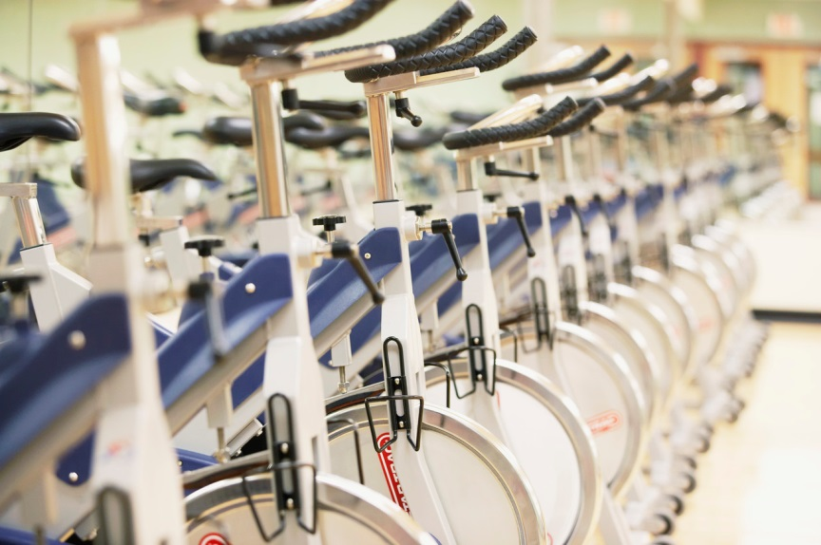
We are here to help you achieve your personal fitness goals!
Contact us:
fitcity.com/Utah
801-FIT-CITY

This flyer is an invitation for you to try our fitness facility for a seven day trial. Sign up at the end of your trial and we will waive your down payment and your first month’s fee! Talk with one of our associates and discuss your fitness goals and a payment plan that is right for you.
Try Our Fitness Center Today!

fit City
fit City

Pricing:
Fitness Center Use: | - $50 down $10 month to month  - $0 down $15 month to month  - $0 down $10 month to month, 3 year contract | Pay In Full:  - One year fitness use: $145
Fitness Classes: | Additional $10 a month to Fitness Center Usage fees | Pay In Full:  - One year fitness use and Classes: $240  - All services: $350
Tanning: | Additional $10 a month to Fitness Center Usage fees | Pay In Full:  - One year fitness use and Tanning: $240  - All services: $350
Child Care: | Additional $10 a month to Fitness Center Usage fees | Pay In Full:  - One year fitness use and Child Care: $240  - All services: $350
We are here to help you achieve your personal fitness goals!
Contact us:
fitcity.com/Utah
801-FIT-CITY

